PROJECT

Smoke Sensor with buzzer Using ARDUINO UNO

In this project The gas sensor module mq-135 consists of a steel exoskeleton under which a sensing element is housed. This sensing element is subjected to current through connecting leads. This current is known as heating current through it, the gases coming close to the sensing element get ionized and are absorbed by the sensing element. This changes the resistance of the sensing element which alters the value of the current going out of it..

Circuit and Working

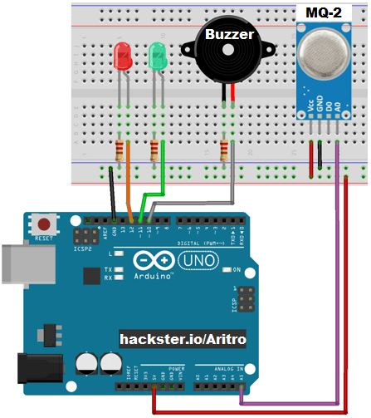

PIN CONNECTIONS

connect red Led to pin 12 arduino;

connect green Led to 11;

connect buzzer to 10;

connect smoke A0 to A5;

and ground to GND and 5v to Vcc

WORKING

The **MQ-135 smoke sensor** consists of a tin dioxide (SnO2), a perspective layer inside aluminium oxide micro tubes (measuring electrodes) and a heating element inside a tubular casing. The end face of the sensor is enclosed by a stainless steel net and the back side holds the connection terminals. Smoke is emitted from the source by burning anything. With the smoke cascade on the tin dioxide sensing layer, the resistance decreases. By using the external load resistance the resistance variation is converted into a suitable voltage variation.

CODE

int redLed = 12;

int greenLed = 11;

int buzzer = 10;

int smokeA0 = A5;

// Your threshold value

int sensorThres = 400;

void setup() {

pinMode(redLed, OUTPUT);

pinMode(greenLed, OUTPUT);

pinMode(buzzer, OUTPUT);

pinMode(smokeA0, INPUT);

Serial.begin(9600);

}

void loop() {

int analogSensor = analogRead(smokeA0);

Serial.print("Pin A0: ");

Serial.println(analogSensor);

// Checks if it has reached the threshold value

if (analogSensor > sensorThres)

{

digitalWrite(redLed, HIGH);

digitalWrite(greenLed, LOW);

tone(buzzer, 1000, 200);

}

else

{

digitalWrite(redLed, LOW);

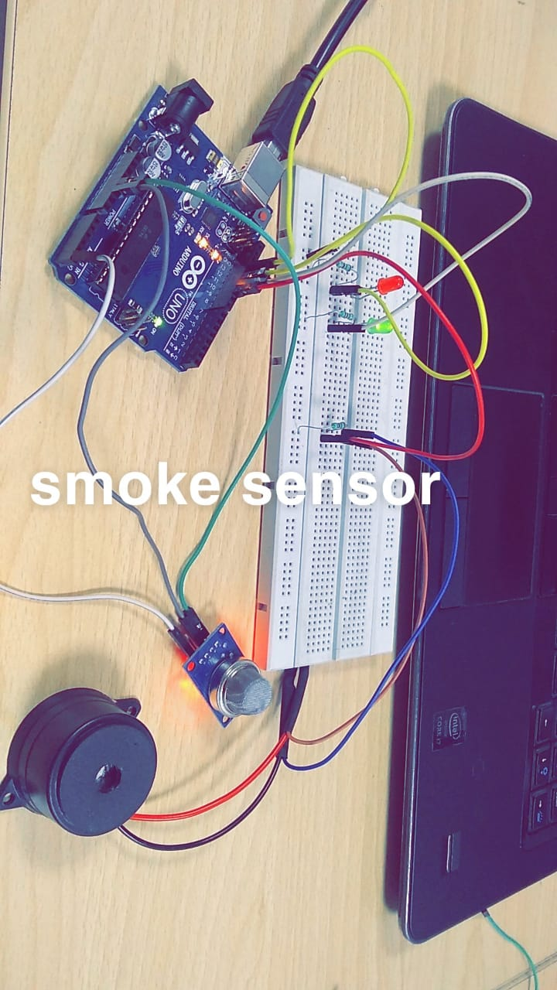 digitalWrite(greenLed, HIGH);

noTone(buzzer);

}

delay(100);

}